Opening speech
at the Multiplier event by INĀRA PUČUKA, NGO Grannies.lv
16.11.2022. Latvia, Valmiera
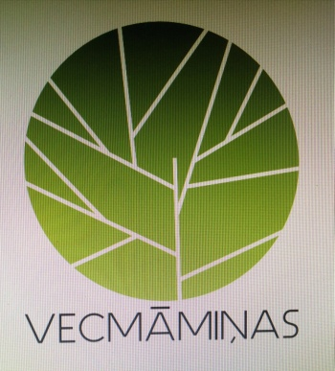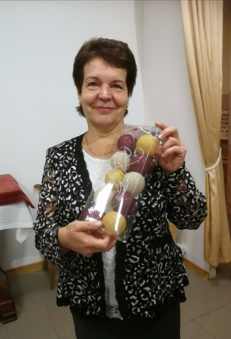

Personally, my closest area of activity is charity, supporting socially vulnerable people, especially children. I worked in Diakonija centre for several years, and it was hard to draw the line - here I was in paid work and doing my job, and here I was doing my heart's work - volunteering.
The project we are working on now is particularly close to my heart: the Erasmus Plus KA 2 project "Go Get Award : How to promote volunteering among seniors". The project coordinators are the Lithuanian side, we, Bulgaria, Slovenia, the Netherlands, Latvia, are partners. The project already has a website where all information and materials will be available - https://gogetaward.eu/
At the end of October, we - the association "Grannies.lv" - hosted the project participants in Latvia. Along with intensive work on the Handbook, the development of the methodology, we offered the project participants to get acquainted with volunteer work in Riga: the Holy Family House, Caritas, the Day Centre "Well of Life" in Bolderaja, the Rehabilitation Centre in Riga, and the volunteer work of the Calcutta Sisters in Daugavpils Street.
The project will continue until the end of January 2023.
You can follow our activities in the Facebook group Vecmāmiņas. lv and on our website - http://erasmuspluska1prague.weebly.com/ or by email : grannies@inbox.lv
Finally, what would I like to wish to my colleagues, representatives of other NGOs and seniors?
Be active! Seniors can also contribute and work for the benefit of society. Don't forget that it is also possible to volunteer as a senior. During our project we collected inspirational stories from seniors in different partner countries. It all seems so inspiring. All you need is the will to act and participate.
16.11.2022.

